Astronomy Quiz #1 (Over Chapter 1) Name_______________________________
Mr. Miller

TRUE OR FALSE:
- ___ The light year is a measure of distance.
- ___ The stars in a constellation are physically close to one another.
- ___ The star Polaris always lies precisely at the north celestial pole.
- ___ The seasons are caused by the precession of Earth’s axis.
- ___ The new phase of the Moon cannot be seen because it always occurs during the daytime.
- ___ A lunar eclipse can occur only during the full phase.
- ___ Solar eclipses are possible during any phase of the Moon.
- ___ Eclipses can only occur during winter and summer months.
- ___ The sun and moon span the same angular diameter as seen from Earth.

FILL IN THE BLANK:
- A _________ is a glowing ball of gas held together by gravity.
- A _________ is a collection of hundreds of billions of stars all gravitationally bound together.
- The solar day is measured relative to the Sun; the sidereal day is measured relative to the ______.
- The apparent path of the Sun across the sky is known as the ___________.
- On December 21st, known as the _______ _______, the Sun is at its _________ point on the celestial sphere.
- Declination measures the position of an object north or south of the _________.
- A _______ eclipse can be seen by about half of Earth at once.

SHORT ANSWER:
- Why does a day measured by the Sun differ from a day measured by the stars?

- Why do we see different stars at different times of the year?

- What is an equinox?

- If one complete hemisphere of the Moon is always lit by the Sun, why do we see different phases of the Moon?

- Why aren’t there Lunar and Solar eclipses every month?

- Draw in and label the Ecliptic, Celestial Equator, and North Celestial Pole in the following diagram for 37 degrees North latitude (San Francisco).
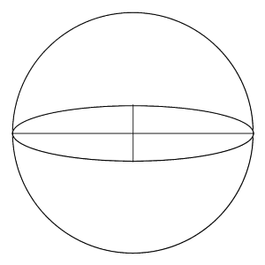

E

N
S

W

- What is one question you have about astronomy?

