Mr. Miller
Astronomy Name: ____________________________

Final Exam

- Pictured below is a portion of the horizon, with the direction you are looking indicated on the figure. For each individual horizon, draw the path of the stars as they appear to move over the course of a single night relative to the horizon for a latitude of 90° South.

East
West

North
South

- Name the planets in order of their distance from the sun (starting with the one closest to the sun).

- The length of the mean solar day is: __________________. (remember units!)

- The length of the sidereal day is: _________________. (remember units!)

- Two parts:
  - The sun cannot ever be directly overhead when you are North of what latitude?

  - What is the name given to this latitude?

- Explain why the earth has seasons from the heliocentric perspective – use drawings and words to explain.

- Draw a picture of a Partial Lunar Eclipse from a) the heliocentric and b) geocentric perspective. Be sure to include and label the Earth, the Sun, and the Moon where appropriate.

a) b)

- Define each type of solar eclipse with words, and sketch what it would look like from the heliocentric perspective:

  - Annular:

  - Total:

  - Partial:

- What is an Astronomical Unit (A.U.)?

- What is the speed of light? (Remember to state your units!!)

- On what celestial bodies has humankind actually set foot (not robots – actual humans)?

- It is the Winter Solstice and you are at the South Pole. Accurately describe (and draw if you wish) the path of the Sun in the sky for the whole day. Be sure to mention the angle of the Sun’s path relative to the horizon and its direction of motion.

- You are in San Francisco (37° N) and it is the Fall Equinox. Accurately describe (and draw if you wish) the path of the sun in the sky for the whole day. Be sure to mention the angle of the Sun’s path relative to the horizon and its direction of motion.

- Kepler’s Three Laws are:

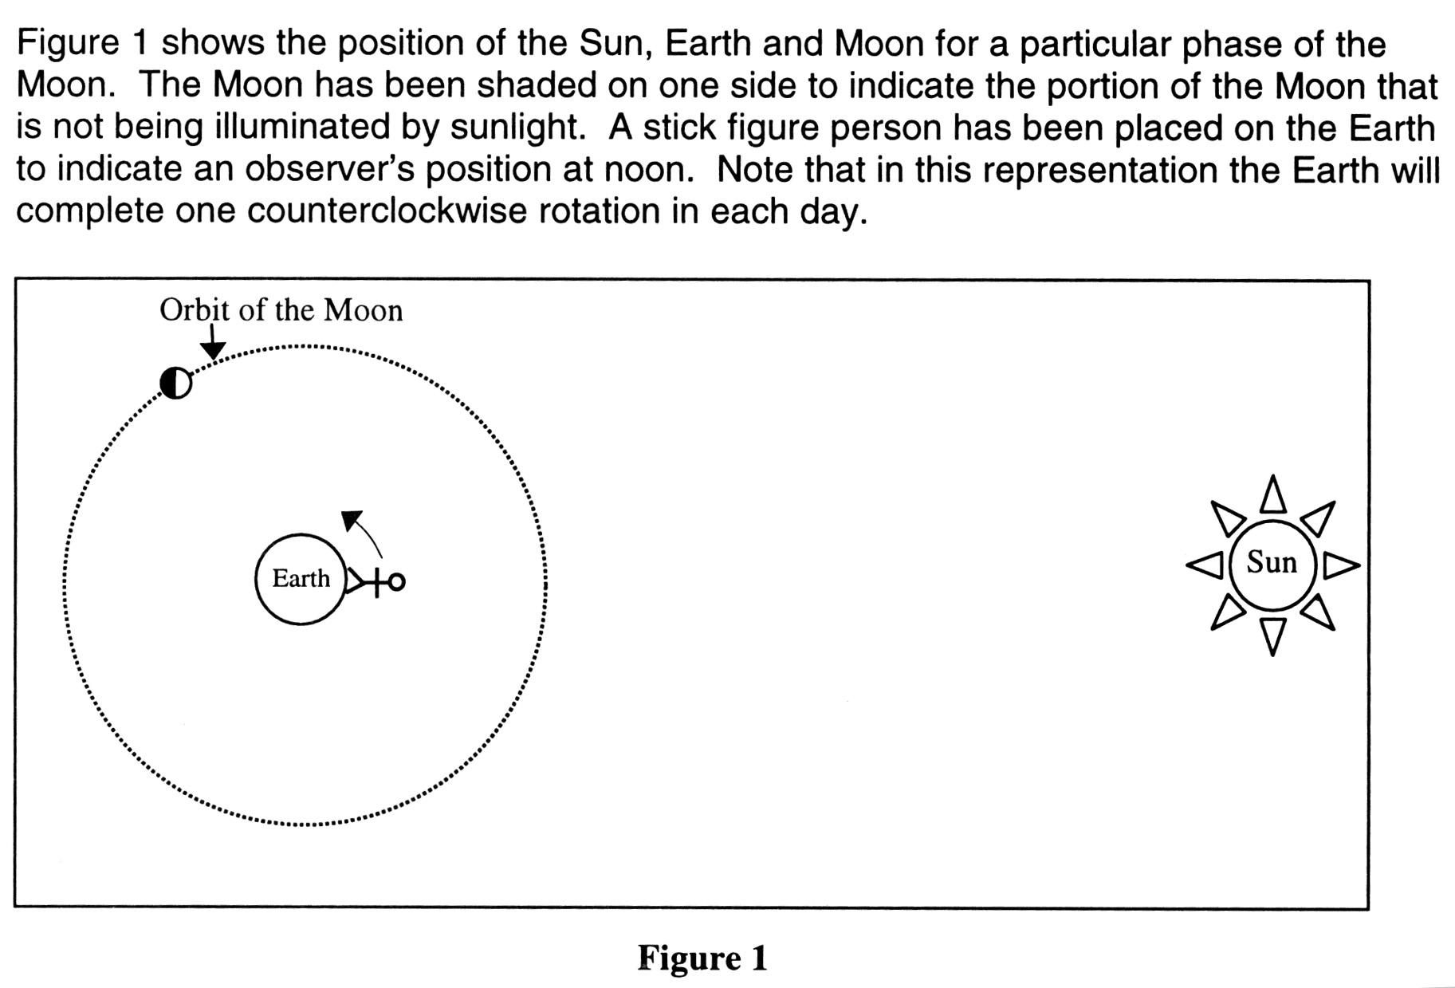

- Use figure one above as a visual aid to help you think about the following question: If the sun set below your horizon about 4 hours ago and the moon is visible directly over your head, what phase is the moon in, and is it waxing or waning?
  - PHASE:
  - WAXING / WANING

- At what time will the first quarter moon rise on the eastern horizon?

- Why do we only ever see one “face” of the moon?

- Is it possible to have a full moon occur when the angular separation between the Sun and Moon in the sky is between 0° and 45°? YES / NO

- Is it possible to have a new moon occur when the angular separation between the Sun and Moon in the sky is between 0° and 45°? YES / NO

- Draw the following phases of the moon as they appear to us from the geocentric perspective:
  - First Quarter

  - Waxing Crescent

  - Waning Gibbous

- Define and explain the concept of the Ecliptic.

- Define and explain the concept of the precession of the equinoxes:

- You are standing on the Arctic Circle (66 ½°N). Over the course of the year, the sun can reach a maximum altitude above the horizon of: _________ degrees, and a minimum altitude of __________ degrees.
- The Tropic of Capricorn and the Tropic of Cancer mark the latitude on the Earth at which the sun:
  - will be directly overhead on a single day of the year.
  - can never be directly overhead on any day of the year.
  - will not rise on a single day of the year.
  - reverses its course in the sky

- Is it possible for the sun to pass through the zenith at a latitude of 20°N? YES / NO

- Name Galileo’s four major astronomical discoveries.

- Which planet in our solar system has the largest diameter?

- Name two astronomical ideas attributable to the ancient Greek astronomer Eratosthenes:

1.

2.

- How many constellations are there in the sky? _______ Why aren’t there any more than this number?

- Describe where on the horizon the Sun rises on the Fall Equinox if you are at a latitude of 30° S.

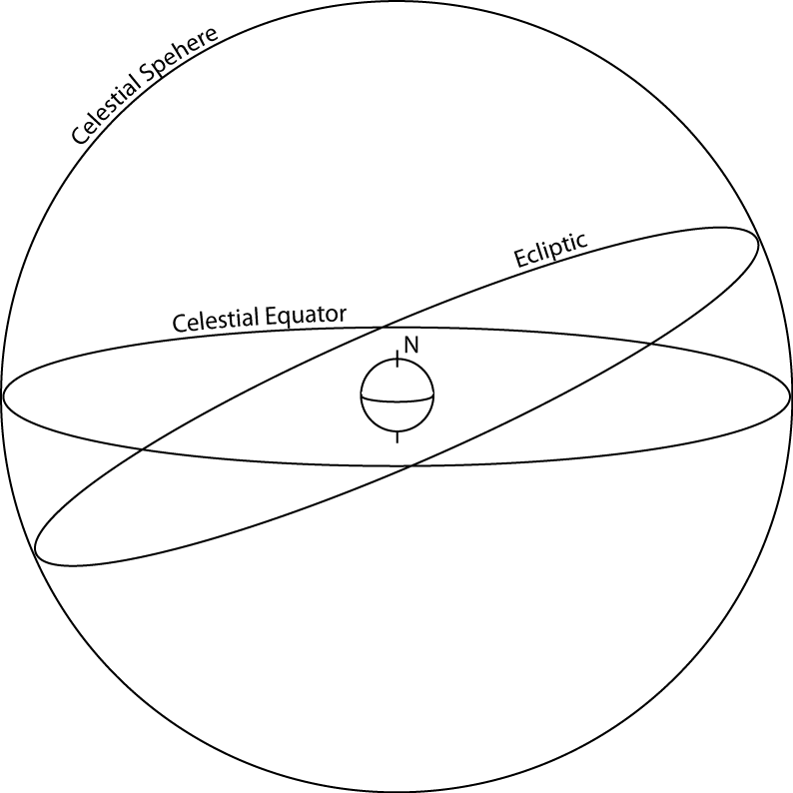
- The following diagram depicts the celestial sphere, with the celestial equator and ecliptic labeled. Label the following points on the diagram:
  - Fall Equinox
  - Spring Equinox
  - Summer Solstice
  - Winter Solstice
  - North Celestial Pole
  - South Celestial Pole

The following questions are EXTRA CREDIT:

Please complete the attached class evaluation sheet and turn in both the test and evaluations sheet.

- Which planet in our solar system has the biggest mountain?

- How far is the Sun from the Earth in Miles?

- A planet has a mean solar day of 35 hours. It has an orbital period of 420 days (of 35 hours each). How long is its sidereal day in hours?

Class Evaluation
CLASS TITLE: __________________ YEAR: ____________

Please take the opportunity to give feedback on this course by answering the following questions. Please be candid and honest – your feedback will help make this a better course for future students. You do not need to sign your name unless you wish.

1. What was the most interesting thing/aspect of this course?

2. What was the least interesting thing/aspect of this course?

3. What could be done to make the course more engaging? (Things like: More/Less experiments? More/Less history? More/Less hands-on activities vs. demonstrations? )

5. Did we cover:
a) Not enough material, I wish we had been introduced to more concepts
b) Too much material, I wish we had spend more time really getting into just the basics
c) Just enough material, I know there is a lot left to explore, but I have a sense for the basics and could explore the topics further on my own with confidence

7. Rate this class on a scale of 1 to 10 (10 = a Lot, 1 = none/not at all) for the following areas:

a) How interesting was this class overall?
b) How fun was this class overall?
c) How challenging was this class overall?
d) The amount of stuff I learned was:
e) My interest in the topic before this class was:
f) My interest in the topic after this class is:

8. Was this class:
a) Too hard
b) Hard but not excessively so
c) Just right
d) Too easy

9. What is something that you don’t think you will forget from this class? What was memorable?

10. What worked well for you in this class?

11. What didn’t work well for you in this class?

12. Think of something you would recommend to make this class better:

13. Please write any other comments you may have.

