Retrograde Motion

When we observe the sky, the Sun, Moon, and stars appear to move from east to west because of the rotation of the Earth (so-called diurnal motion). However, objects such as the Space Shuttle and many artificial satellites appear to move from west to east. These are direct satellites (they actually orbit the Earth in the same direction as the Moon), but they orbit the Earth faster than the Earth itself rotates, and so appear to move in the opposite direction.

As seen from Earth, the planets beyond Earth's orbit (Mars, Jupiter, Saturn, Uranus, and Neptune) appear to periodically switch direction as they cross the sky. Though all stars and planets appear to move from east to west on a nightly basis in response to the rotation of Earth, the planets generally drift slowly eastward relative to the stars. This motion is normal for the planets, and so is considered direct motion.

However, since Earth completes its orbit in a shorter period of time than the planets outside its orbit, we periodically overtake them, like a faster car on a multi-lane highway. When this occurs, the planet we are passing will first appear to stop its eastward drift, and then drift back toward the west. Then, as Earth swings past the planet in its orbit, it appears to resume its normal motion west to east. Asteroids and Kuiper Belt Objects (including Pluto) also exhibit apparent retrogradation.

Mars goes through apparent retrogradation every 25.7 months. The more distant outer planets retrograde more frequently. The period between such retrogradations is the synodic period of the planet.

This apparent retrogradation puzzled ancient astronomers, and was one reason they named these bodies 'planets' in the first place: 'Planet' comes from the Greek word for 'wanderer'. In the geocentric model of the solar system, retrograde motion was explained by having the planets travel in deferents and epicycles. It was not understood to be an optical illusion until the time of Copernicus.

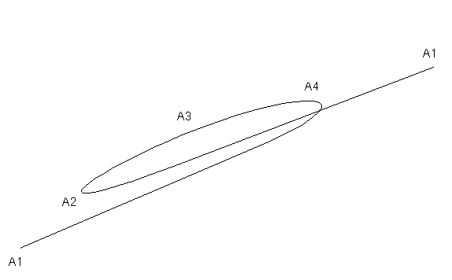
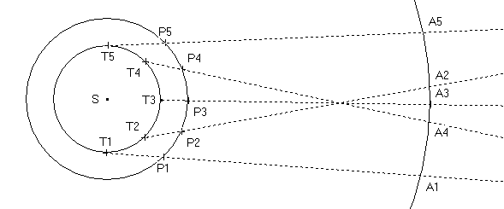
A5

