Astronomy Name: ______________________
Mr. Miller

The Orbit of Mars from Earth

Materials:
Straight edge, a planisphere.

Purpose:
This exercise will allow you to study graphically the retrograde motion of Mars during the period from January 1970 to October 1970. This apparent wandering of Mars in the sky results from the combination of its own motion and the Earth's orbital motion.

Plotting the Position of Mars:
Table 22-1 gives the right ascension and declination of Mars for various dates in 1970 when retrograde motion occurred. Plot the points on Figure 22-1 and connect the points chronologically by a smooth curve. You will need to determine what each ‘tick’ on the horizontal and vertical scales is worth in the appropriate units.
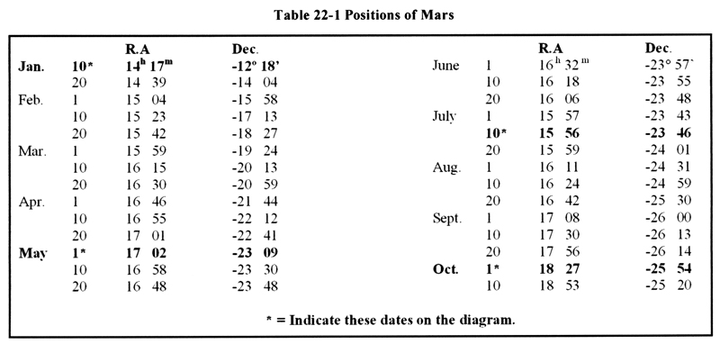
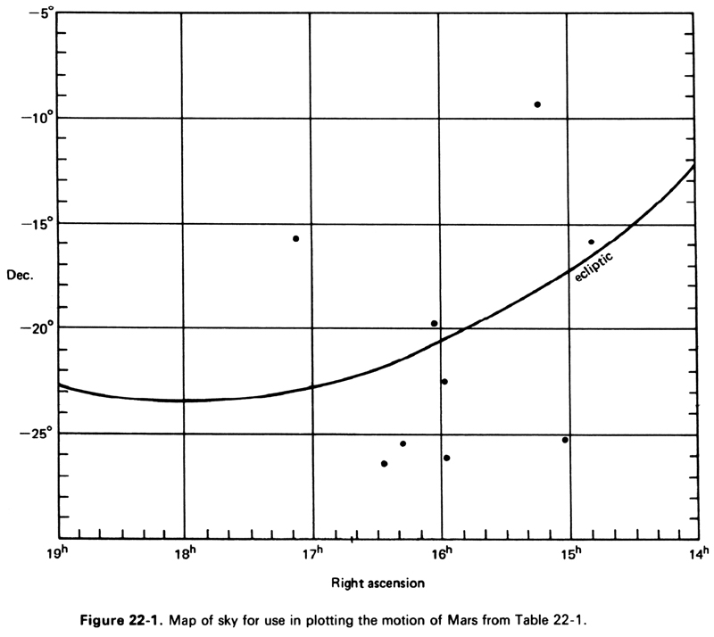

PROBLEMS:

1. What is the ecliptic?

2. The orbit of Mars never takes it far from the ecliptic. Why?

3. What is the meaning of the term "retrograde motion"?

Retrograde Motion:

In Figure 22-2 connect the corresponding points in the two orbits by lines drawn to intersect the vertical line at the right. Number these intersection points on the vertical line as shown by the example.

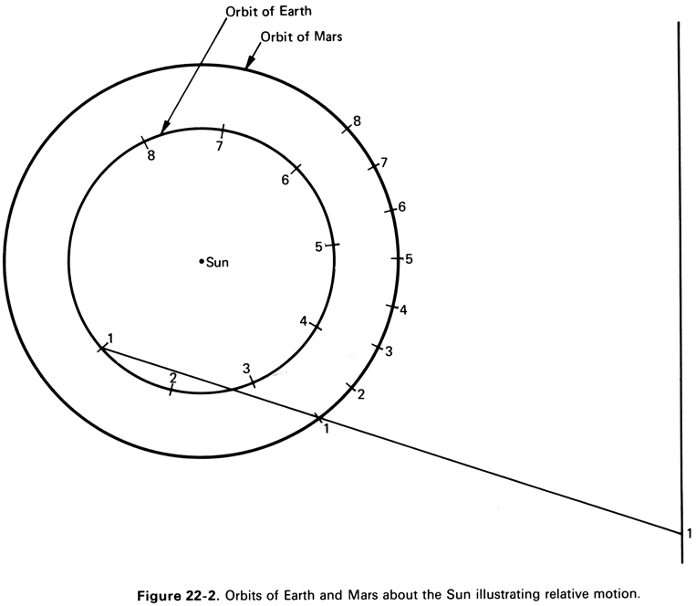

Both planets revolve about the Sun in the same direction, but Earth has a higher orbital speed so that it periodically overtakes Mars. As Earth passes Mars at 5, Mars appears to move backward, to the west in the sky, even though it is actually moving to the east in its own orbit. As Earth approaches position 7, Mars again resumes its eastward motion in the sky. This apparent temporary westward motion of Mars, as the Earth moves between it and the Sun, is called retrograde motion.

