Astronomy Name: ______________________
Mr. Miller

The Orbit of Mercury

Materials:
Protractor, millimeter rule, sharp pencil.

Purpose:
How do we know what the orbit of a planet is like? At first glance this appears to be a difficult question, but in many cases it is surprisingly easy to derive an orbit from basic observations. In this exercise you will use a set of simple observations, which you could have made yourself, to discover the size and shape of the orbit of Mercury. You will be repeating work that Johannes Kepler did to formulate his laws of planetary motion. Kepler made his first discoveries while studying the orbit of Mars. He then extended his analysis to the six planets then known. We will see how he studied Mercury.

Observations:
The ancient astronomers of Greece were familiar with planet Mercury, but they did not recognize it as the same object when it appeared in the evening sky and in the morning sky. It was known as Apollo when seen in the morning sky and as Mercury when seen in the evening sky. Sixteen hundred years later the motions of the planets were observed and recorded by the Danish astronomer Tycho Brahe. Brahe's records covered a period of 20 years, and on his death in 1601 these records were taken by one of his assistants, Johannes Kepler.

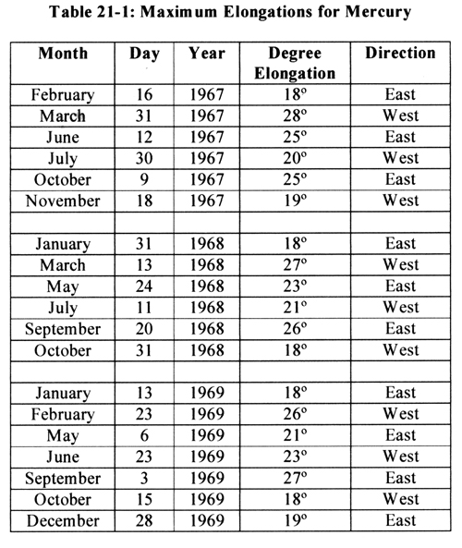
From Brahe's records Kepler was able to find the maximum angular distance from the Sun that Mercury reached during each of its passages. You could make the same observations, but to save time a list of these distances, called maximum elongations, is given in Table 21-1. These data were taken from observer's handbook for the years 1967-69. You could obtain similar data from the handbook for the current year. These data contain the dates on which Mercury was at its maximum elongation, the angular distance, and the direction from the Sun.
Drawing the Orbit:

Figure 21-1 shows the orbit of the Earth with the dates marked to represent the position of the Earth in its orbit throughout the year. The scale below the orbit is marked in astronomical units and will enable you to make measurements on the diagram in astronomical units. The Sun is represented by the dot at the center of the Earth's orbit.

As you draw on the diagram use a sharp pencil; sharp so you can be accurate, and pencil so you can make corrections as necessary. (The width of a sharp pencil line on this diagram is about 100,000 km!)

Now plot each of the elongations as follows: Locate the date of the maximum elongation on the orbit of the Earth.
Draw a light pencil line from the position of the Earth to the Sun, or line up a piece of paper to mark this line temporarily. Center a protractor at the position of the Earth and construct a line so that the angle from the Earth-Sun line to this constructed line is equal to the given maximum elongation. Extend this line across the diagram well past the Sun but not all the way to the other side of the Earth’s orbit. It represents the direction toward Mercury. Remember, facing the Sun from the position of Earth, eastern elongations are to the left as in Figure 21-2. In each case the planet Mercury will lie somewhere along the line you have drawn. As you draw more lines, you will see the orbit taking form.
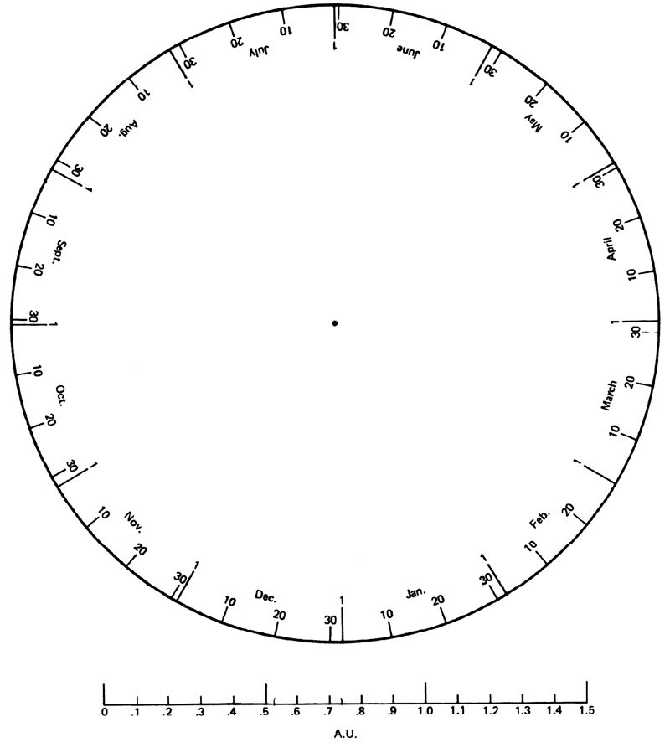

After you have plotted the data you may sketch in the orbit of Mercury. The orbit must be a smooth curve that just touches each of the elongation lines you have drawn. The orbit should not cross any of these lines.

Figure 21-1
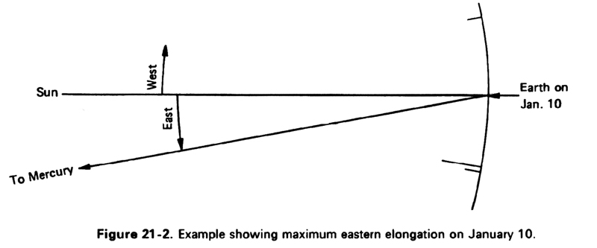

The Shape of the Orbit:

PROBLEMS:

1. Does it appear that the curve you have drawn is not a circle? How could you be sure?
Kepler had the same problem; his circles didn't fit either. At last he hit upon the idea of using ellipses for the orbits. They fit. Through the Sun draw the longest diameter possible in the orbit of Mercury. This is the major axis of the ellipse – label it on the diagram. Measure the length of the major axis, and bisect it to find the center of the ellipse. Draw the minor axis through the center perpendicular to the major axis, and label it on the diagram.

2. What is the semimajor axis a of Mercury's orbit in astronomical units (A.U.)? Does your result agree with the standard value?

(a) Measured semimajor axis: a = ____________

(b) Standard value: a = 57,910,000km or 0.38709893 A.U.

3. Use your measured value of a to calculate the sidereal period P of Mercury in years using the appropriate law from Kepler. To convert to days, multiply the sidereal period in years by 365.26.

(a) Calculated period: P = ___________years = ____________days.

(b) Standard value: P = 87.969 days or 0.2408 years

4. The Sun lies at one of the foci of the ellipse. Measure the distance from the Sun to the center of the ellipse and call it c. If we divide c by the semimajor axis a we get the eccentricity e of the orbit. Calculate e for your orbit and compare it with the standard value.

(a) Calculated value: e =

(b) Standard value: e = 0.2056

The Distance to Mercury:

On October 15, 1969, Mercury was at greatest elongation west. Fifteen days earlier, on October 1, 1969, Mercury was 9° west of the Sun. Plot and label the position of Mercury on October 1, 1969 on figure 21-1.

PROBLEMS:

6. What was the distance from Earth to Mercury on October 1, 1969 in astronomical units?

7. From measurements made on your diagram, determine the minimum possible distance from Earth to Mercury.

The Accuracy of the Result:

This is a simple exercise and, if you were careful and used a sharp pencil, your results for the orbit of Mercury will be surprisingly accurate. The orbits of most of the other planets are much less eccentric than the orbit of Mercury, and the results from a graphical study of these orbits would not be accurate enough to measure the eccentricities of the orbits. When Kepler studied the orbits of the planets, he did not depend on a diagram but, rather, he built a mathematical model of the orbits based on the observations. His analysis of these orbits led him to a statement that has become know as Kepler's first law of planetary motion: The orbits of the planets about the Sun are ellipses with the Sun at one focus.

PROBLEM:

8. What are some of the assumptions that we have made that affect the accuracy of our results? List as many as you can!

